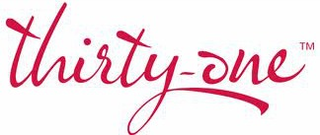
FIRST HOSE COMPANY OF BOONSBORO PRESENTS
Thirty~One & CASH BINGO
Friday April 14, 2017
5 SAINT PAUL STREET BOONSBORO
Doors open at 5 PM, Bingo Starts at 630 PM
TICKETS $20, available at the door
Tip Jars, door prizes, ALL Bags are filled!
Food and drinks sold on premises, please NO OUTSIDE FOOD OR DRINK
Any questions call Jessie at 240-313-5454, Kim 240-315-1660
Thank you for supporting us so that we may better serve our Community!!

